
SPORT TYNEDALE

VOLUNTEER COACH DEVELOPMENT
APPLICATION FORM

Sport Tynedale has a fund to help volunteer coaches achieve recognised coaching qualifications, to be used to coach and develop sport in our area.

By submitting this form, the applicant and their club agree to the grant conditions, which are:

- You must be a volunteer coach – i.e. unpaid (reasonable expenses may be paid)
- You must coach, or be committed to coach, at a club in our area. The area is West Northumberland (Tyne Valley west of Newcastle, and Ponteland area: see map at end of this form)
- Your club/organisation must be affiliated to Sport Tynedale by a listing on our website (this is free, and easy to do on the website: https://www.sport-tynedale.com/add-a-club)
- If approved, we will fund up to £150 or half the cost of the course, whichever is less
- To make our money go further, we limit the number of awards per club per year
Size of Club No of Members Max awards per year
Small Up to 25 2
Medium 26-49 3
Large 50+ 4
- We cannot fund retrospectively– your activity must still be to happen. We aim to make decisions within a week of application
- The grant will normally be issued by bank transfer to the club where the coaching will take place: we will request bank details when the award is approved
- In the event of the applicant not completing the course, the money must be returned to Sport Tynedale
- We expect successful applicants, if requested, to take part in publicity to help us promote Sport Tynedale (unless there are particular circumstances in which this would not be appropriate). Equally we are very pleased to be part of any promotional activities which may help clubs or coaches attract sponsorship or grants, and/or encourage participation in sport.

Please contact us on grants@sport-tynedale.com if you are not sure about eligibility or have any other questions.
Section A : About the coach

Name
Age if under 18
If Under 18: Name of Parent/Guardian
Address

Post Code
Email (Parent/Guardian if Under 18)
Telephone No
(Parent/Guardian if Under 18)
School ( if at school)
Sport
Club / organisation where you will coach
Name and level of Course you want to attend
Date(s) of course
Venue
Cost of course
Any additional costs you will incur - details and costs
Other funding you have towards course (amounts and sources of funding)

Section B: about the Club or Organisation where the coaching will happen

Contact Name:

Position in Club:

Contact details: (Email and telephone)

How will the applicant enhance your club / organisation through achieving this coaching award? Give details of how often they will coach, approximate numbers to be coached, and details of how participants will benefit.

Section C: Declarations by Club/Organisation and Applicant Coach

We confirm eligibility for grant and compliance with the conditions of grant aid as set out in this form.

YES/NO
We will take part in publicity organised by Sport Tynedale in relation to any award of grant

YES/NO
If NO, please state reason:

Signed (Applicant) (Parent/Guardian if Under 18)

Date
Signed (Club/Organisation Contact)

Date



Sport Tynedale Area Boundaries

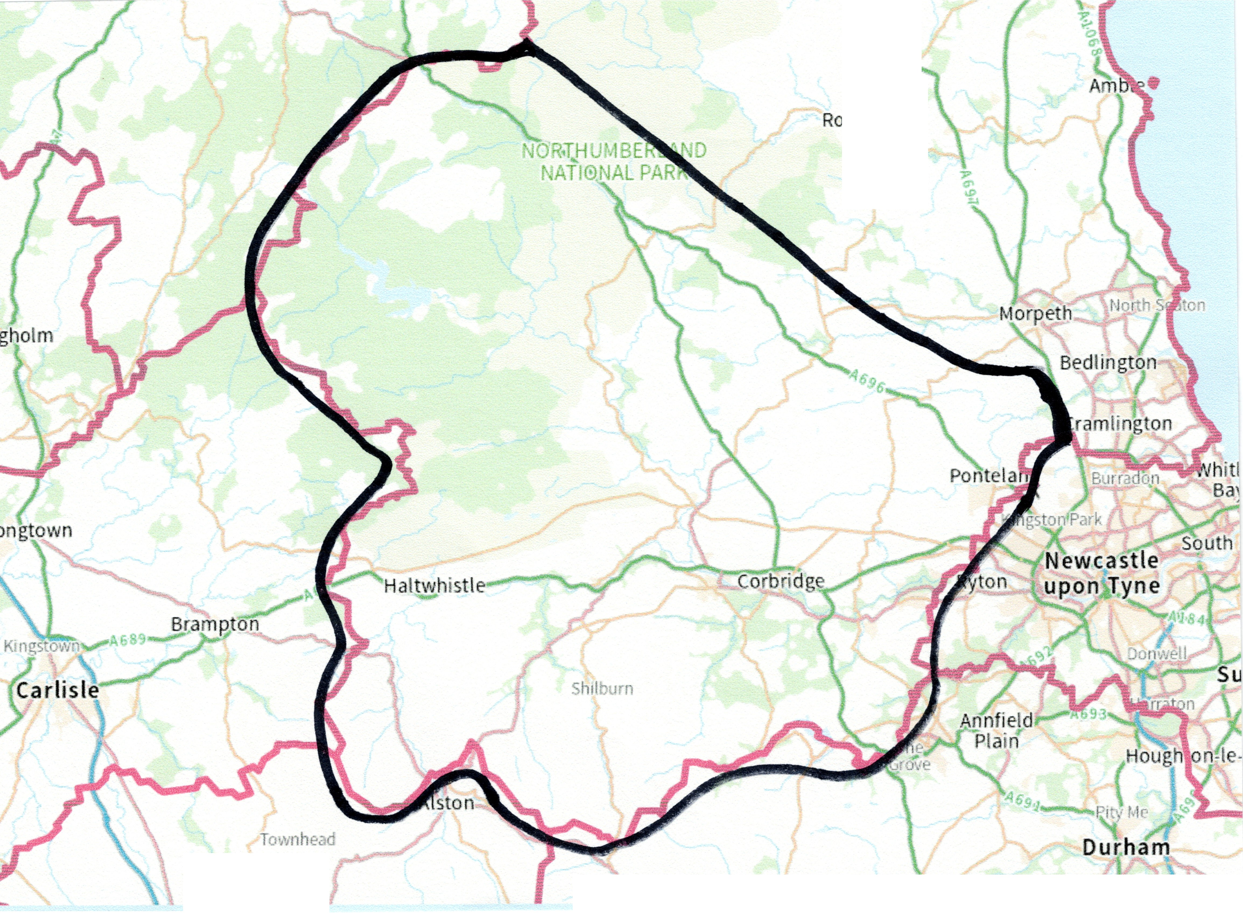

Rothbury
Tow1ifoot
Stanhope
Tow Law
Brm·mey

Rochester
Elsdon
(outside area)

Cambo
Belsay

Sport Tynedale’s boundaries, marked approximately with the thick black line, follow the Northumberland County boundaries to the West, South and South East. To the East the area includes Ponteland and then the boundary runs a few miles north-east of the A696 to include Whalton, Belsay, Cambo, Kirkwhelpington and Otterburn (but not Elsdon which is in the Alnwick and District Sports Council area).If in doubt please contact us on admin@sport-tynedale.com.

