
SPORT TYNEDALE

INDIVIDUAL AMATEUR DEVELOPMENT FUND APPLICATION FORM

Sport Tynedale has a fund to help talented individuals to develop their sporting skills at Area, County, Regional, National or International level.

By submitting this form, the applicant and their club agree to the grant conditions, which are:

- You must be an amateur sports person – i.e. unpaid (reasonable expenses may be paid)
- You must live in our area, and/or take part in sport at a club or school in our area. The area is West Northumberland (Tyne Valley west of Newcastle, and Ponteland area – see map at end of form)
- If a grant is approved, we will fund a maximum of £250 in any 12 month period.
- Grants can be used for any reasonable expenses to help you progress in your sport and enhance performance, for example specialist kit and equipment (normally excluding clothing), travel, accommodation, coaching, event entries
- We cannot fund retrospectively– your activity must still be to happen. We aim to make decisions within a week of application.
- The grant will normally be issued by bank transfer; we will request bank details when the award is approved
- Successful applicants are strongly encouraged to keep us in touch with their progress in sport.
- The grant must be used for the purpose requested; if it is not, Sport Tynedale has the right to reclaim the money.
- We expect successful applicants, if requested, to take part in publicity to help us promote Sport Tynedale (unless there are particular circumstances in which this would not be appropriate). Equally we are very pleased to be part of any promotional activities which may help clubs or sports players attract sponsorship or grants, and/or encourage participation in sport.

Please contact us on grants@sport-tynedale.com if you are not sure about eligibility or have any other questions.

Section A: about the applicant

Name
Age if under 18
If Under 18: Name of Parent/Guardian
Address

Post Code
Email (Parent/Guardian if Under 18)
Telephone No
(Parent/Guardian if Under 18)
School (if at school)
Your Sport(s)
Club(s) and/or School where you take part
What level of sport are you competing at? Please give examples of recent performances.
How much are you applying for? Please give details of how any awarded funding will be spent.
How will a grant help you to develop and improve in sport?
Section B to be completed by an official of the affiliated club, school or National Governing Body

Contact Name:

Position in Club/School/Governing Body:
Telephone:
Email:
Please give details of how you support this application, e.g the ability, attitude and potential of the applicant

Section C: Declarations by Club/Organisation and Applicant

We confirm eligibility for grant and compliance with the conditions of grant aid as set out in this form.
YES/NO
We will take part in publicity organised by Sport Tynedale in relation to any award of grant
YES/NO
If NO, please state reason:

Signed (Applicant) (Parent Guardian if under 18)
Date
Signed (Club/Organisation Contact)
Date



Sport Tynedale Area Boundaries

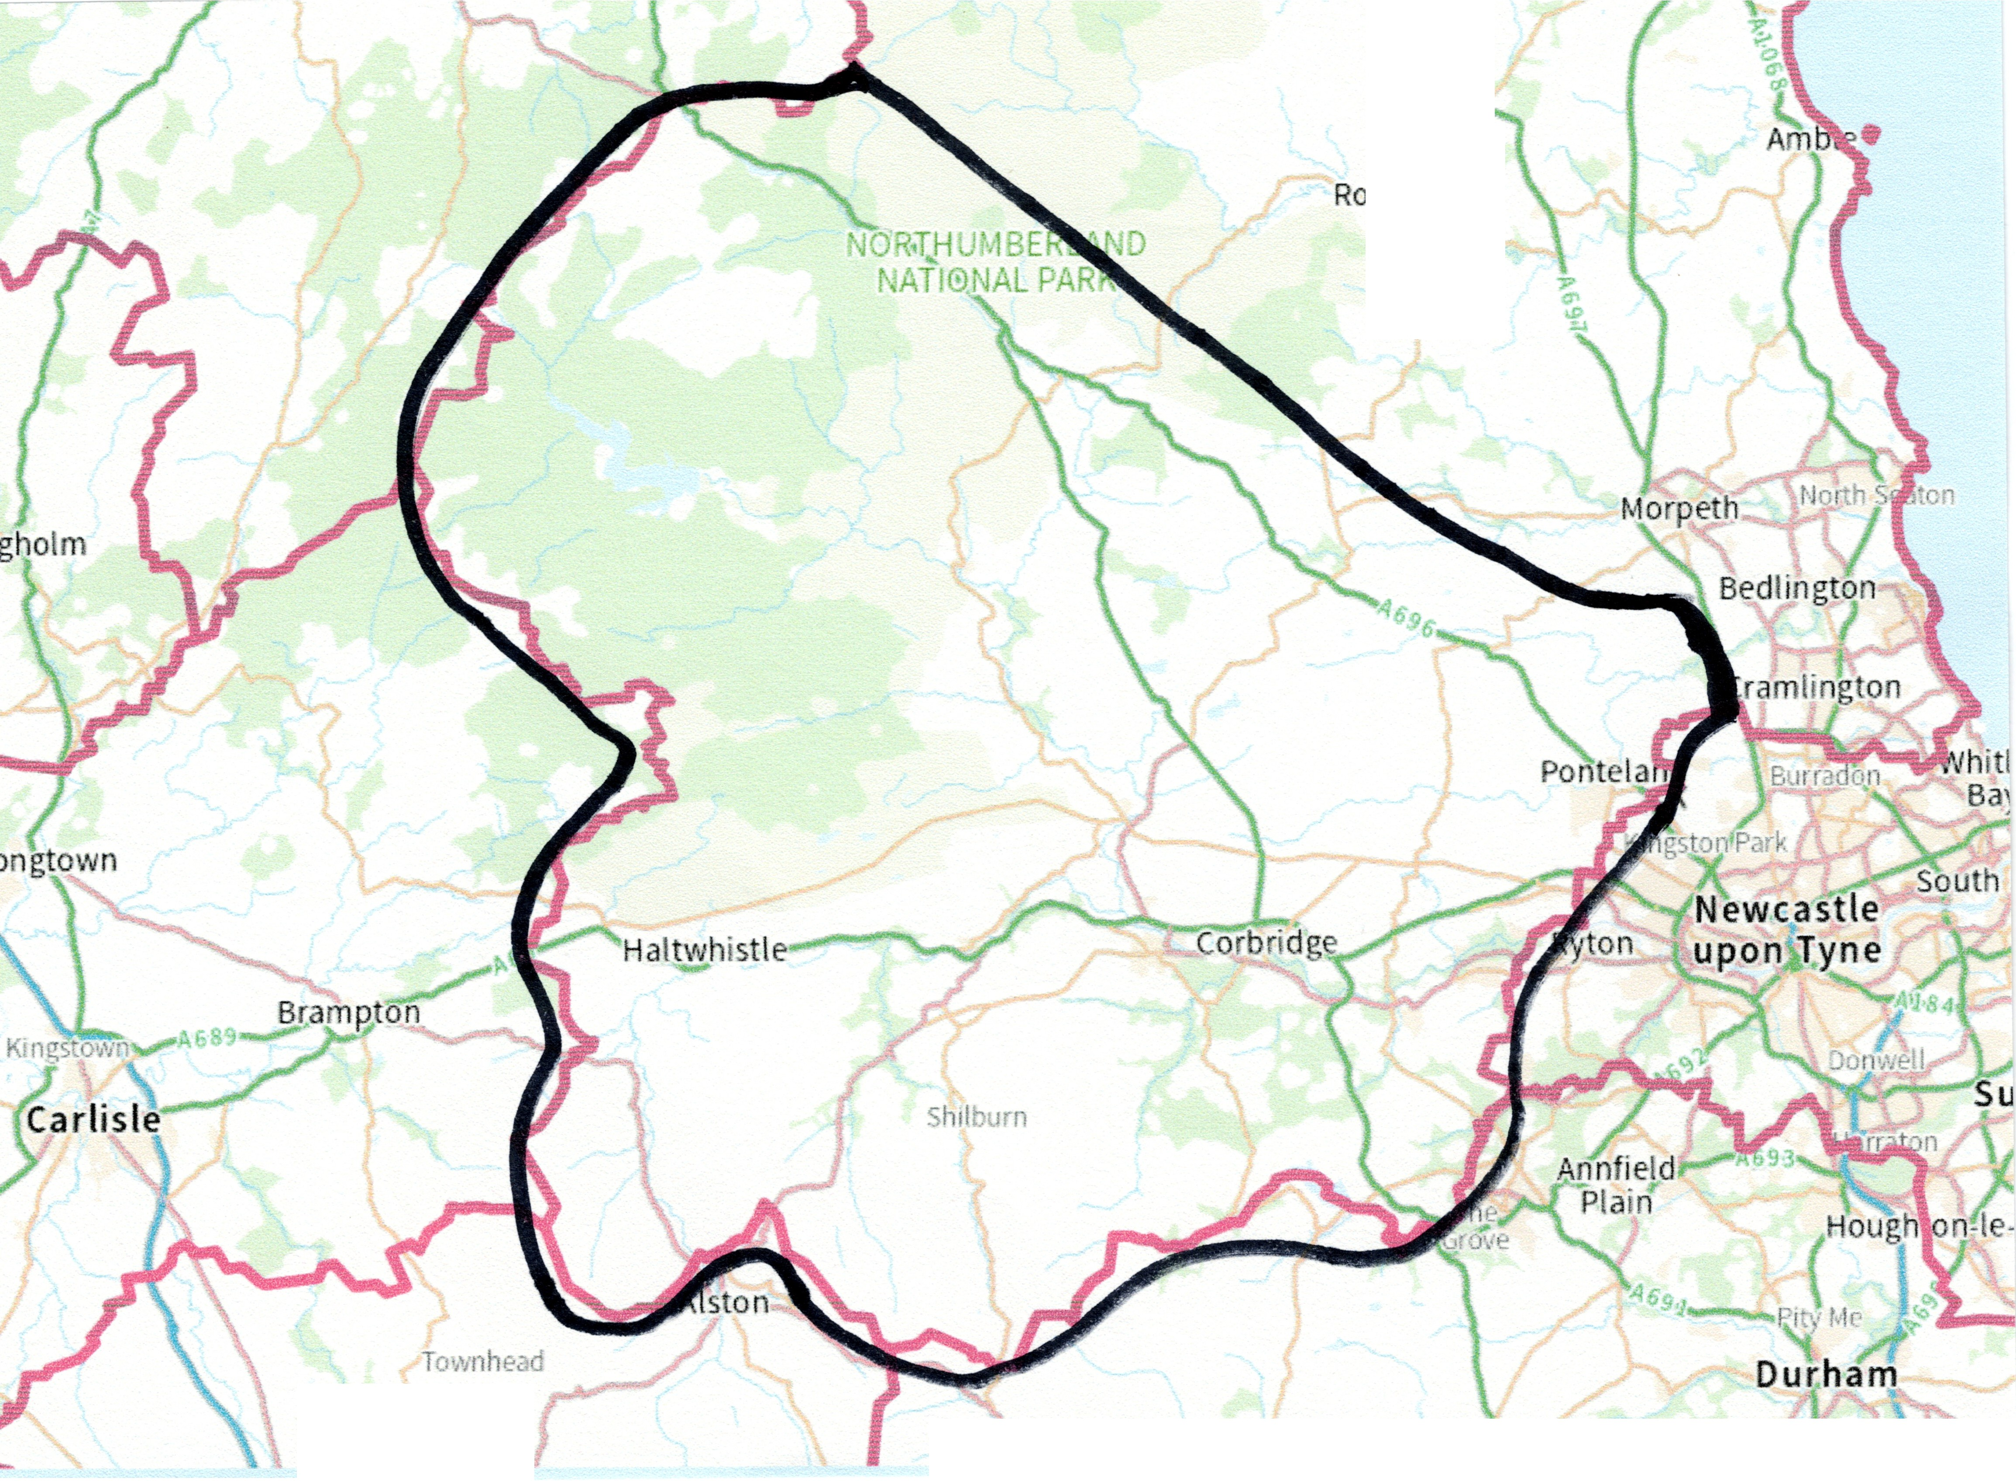

Rothbury
Tow1ifoot
Stanhope
Tow Law
Brm·mey

Rochester
Elsdon
(outside area)

Cambo
Belsay

Sport Tynedale’s boundaries, marked approximately with the thick black line, follow the Northumberland County boundaries to the West, South and South East. To the East the area includes Ponteland and then the boundary runs a few miles north-east of the A696 to include Whalton, Belsay, Cambo, Kirkwhelpington and Otterburn (but not Elsdon which is in the Alnwick and District Sports Council area).If in doubt please contact us on admin@sport-tynedale.com.

